PROGRAMME FOR COVID VACCINATION CAMP (18.09.2021)

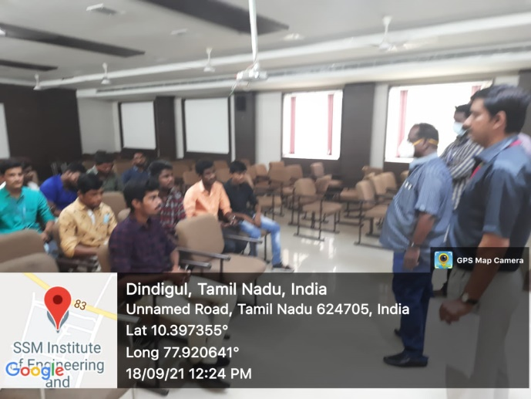 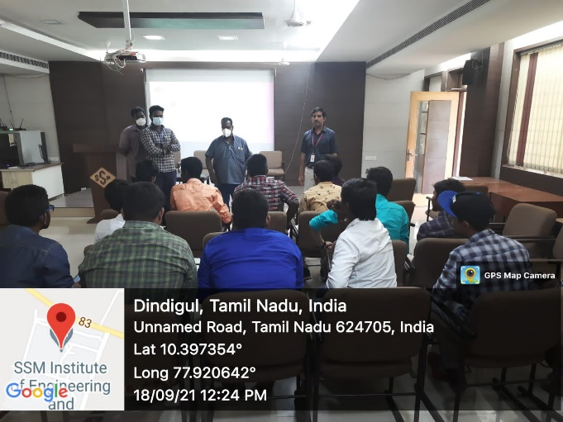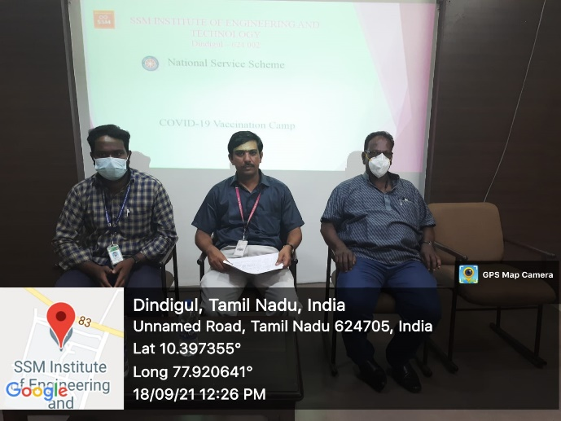

COVID Vaccination Programme was held at SSMIET campus on 18.09.2021 successfully.

Totally 15 students attended this Programme under the NSS / SSMIET.

NSS Coordinator

R.SATHEESH BABU Principal